US Sales Force
Promotion Mix & Optimization Process Documentation

Promotion Mix Response and Targeting Team
Sales Force Operation
June 2005

Contents

- Introduction

- Promotion Response & Mix Optimization Flow Chart

- Data Structure and Preparation

- Data Collection & Validation – put the description of the variables collected
- PRM – data collection from the external sources.
- US Answers
- LPM

- Promotion Mix Model
Model Structure
- Model Specification Explore – make sure that the current model is described
- Fitting the Proc Mixed Model
- Model Validation
      - Hold out analysis

- Promotion Optimization

1. Communicate cross-function to collect business assumptions
2. Optimization Objective Function
3. Integration Constrains to optimization
- Output & Business Decision Support

- Appendix

- Introduction and Purpose

Promotion mix is the analytical process used by LMR, SFS and marketing to reconcile spend level and message mix across different channels for all products as well as portfolio of products.

The purpose of this document is to institutionalize the technical process of promotion mix response analysis and promotion optimization to support for cross-brand call plan optimization and promotion mix allocation within each brand.

The document is trying to catch every detail of data process and utilization of technical methodology in order to provide guidance for internal knowledge transfer within SFO and capitalize organization learning.

For any other external communication purpose, the document could be considered as a technical reference only.

Data Structure and Preparation

Promotion Response & Mix Optimization Flow Chart

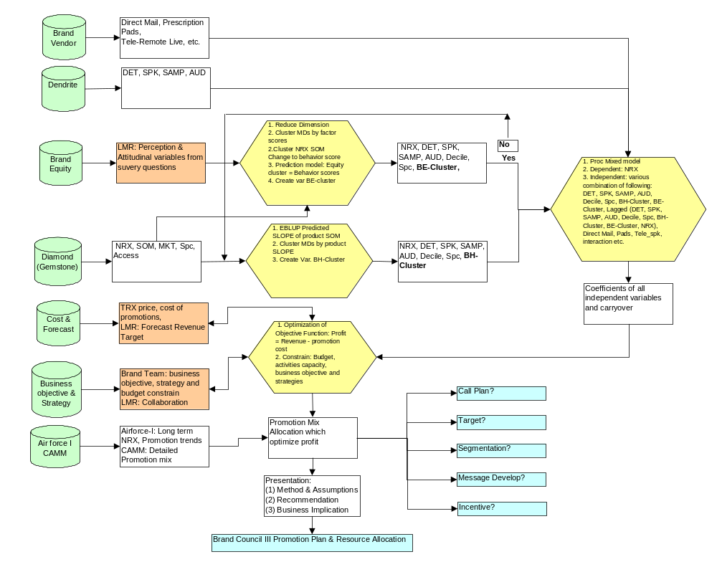

The flow chart illustrated all data sources and business input as well as intermediate output in every step in the whole process. The major data source includes:
A. NRX ----- Diamond & Gemstone.
  - DET, AUD, SPK ----- Dendrite: MD.RAW_DETAILS.
  - SAMP ----- MD.RAW_SAMPLES.
  - Deciles ----- Calculated based on Market NRX or collect from Diamond
  - Other Promotion Intervention ----- Brand Teams and Vendors
  - Brand Equity Data & Forecasting ------ Lilly Market Research
  - Promotion Cost Assumptions ----- Brand Teams and Financial Department
  - Competitive Data ----- CAMM & Air Force I (IMS).

Data Collection & Validation

A. Reorganized data by subject (MD) and time .
B. Merge NRX, DET, AUD, SPK, SAMP.
- Delete subjects not detailed (eg. less than 1 or 2 DETs in single month during 24 month).
- Validate and process brand equity data
E. Subset data NRX (10%) for model calibration & development.
- Merge behavior cluster or brand e cluster with NRX and promotion data set for modeling.
- Collect & validate promotion cost, revenue forecasting
- Align constraints, business strategy, objective, promotion activity and budget constrains for promotion mix optimization

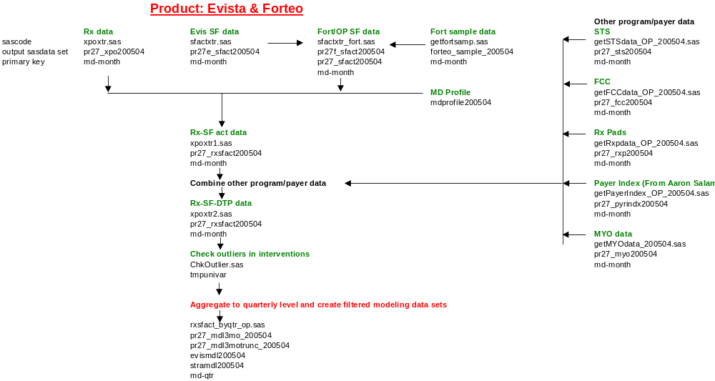

3. Mix Model Structure

Dependent Variable (NRX) = lag(NRX) + Common Promotion Variables (DET, AUD, SPK, SAMP) + Other DTP Variables (ex: Prescription Pads, Direct Mail, Remote SPK) + Cluster Variable (ex: Deciles, Behavior Cluster, Attitude Cluster)

Promotion Mix Model

Extensive literature review was conducted to select statistical methodology for model development. Both generalized estimating equations (GEEs in PROC GENMOD) and Linear mixed model in PROC MIXED are explored because both of them have advantage to handle unbalanced data with unequally spaced time points and subjects observed at different time points. Obviously, any promotion activities are highly unbalanced at different time points. However, current data set could not converge in PROC GENMOD.

1. Model Specification Explore
- Conduct an exploratory data analysis by illustrating the cross-sectional and longitudinal relationships in the data;
- Identify theoretical framework what activities will be expected to influence MDs prescriptions.

2. Fitting the Proc Mixed Model

- Fit a complex mean model and select covariance structure through sample variogram.
- Eliminate unnecessary terms in the complex mean model to fit a parsimonious model.
- Finalize model structure and output co efficiency estimates for optimization.
- Evaluate model assumptions and identify potential outliers.

Promotion Optimization

Optimization is a key stage to integrate robust statistical analysis result with brand team’s business objectives and inputs to optimally allocate resources at right channel, right target and right promotion mix activities.

Communicate cross-function to collect business assumptions

- Financial Assumption: collect cost assumptions of all promotion activities & assumptions of revenue from Finance Department.
- Revenue Assumption: collect revenue forecast assumption for next plan year from LMR forecasting team.
- Brand Objective Assumption: Collect brand team assumption about business strategies, objectives, budget and specific constrains in terms budget, mix, channel etc.
- Other assumption: refill rate, number of MDs by segment, cluster in targeted population.

Optimization Objective Function

    - Objective Function: Maximize Profit = Revenue – Promotion Cost.
    - Revenue =Incremental Nrx (response curve generated by promotion mixed model) * Refill Rate ( Trx/Nrx)*Calibfactor (1+growth rate in revenue forecasting)*MDs(by segment & cluster).
    - Promotion Cost =Incremental Cost by DET, SAMP, SPK* total DET, SAMP, SPK etc.

Integration Constrains to optimization
    - Activities capacity (range) constrains: Certain promotion activities will be constrained by its capacity.
    - Budget constrains: Overall available budget for the brand and strategic budget allocation for long-term business objectives.
    - Revenue constraint: forecasting revenue for detailed segments.
    - Targeted segmentation constrains: Strategic targeted segments with pre-allocated resources.

Output & Business Decision Support
    - Integrated analysis (competitive analysis, brand equity analysis, promotion response analysis, optimization analysis) and interpret findings and business implication.
    - Two way communication with LMR, Brand Team and Sales Force Administration to integrate finding with business decision.
    - Provide analysis inputs for call plan, segmentation, target and Brand Council III promotion planning.

Appendix

Appex-1 Summarized Mixed Model & Optimization Function

1. Mix Model

Mix Model: Ln(NRX_{t} +1) = β₀ + λ * Ln (NRX_{t-1} +1) + β₁ * DET + β₂ * SAMP
+ β₃ *AUD + β_{4 *} SPK + …;
Where DET --- Ave. No. of details by month
SAMP ---Ave. No. of samples by month
AUD --- Ave. No. of Sample by Month
SPK ---Ave. no. of Sample by Month
T ---12

Ln(NRX_{t} +1) = β₀ + λ * Ln (NRX_{t-1} +1) + Σβ_{i} * Pi
Where P_{i} = Promotion and Interactions (Det, Samp, etc.)

NRX_{t} +1 = e^{(β0 + Σβi * Pi)} * (NRX_{t-1} +1) ^{λ}
NRX_{t} = (NRX₀ +1) ^{λt} * e(β0 + Σβi * Pi) (1+ λ + λ2 + … + λt-1) - 1
Where NRX₀ = Historic Average NRX /Month/MD

Incremental: Δ NRX_{t} = NRXt (Σβi * Pi) – NRXt (0)
Where NRX_{t} (Σβi * Pi) --- NRX with promotion activities
NRX_{t} (0) ---- All promotion activities are zero

Δ NRX_{t} = (NRX₀ +1) ^{λt} * (e(β0 + Σβi * Pi) (1+ λ + λ2 + … + λt-1) - e^{(β0 ) (1+ λ + λ2 + … + λt-1)} )
=NRX_term * (e^{(β0 + Σβi * Pi) *Tlag} - ^{β0 )} - e^{(β0 ) *Tlag})
Where NRXt_term = (NRX₀ +1) ^{λt}
Tlag = (1+ λ + λ2 + … + λt-1)

2. Optimization

Objective Function: Max = Σ Δ NRX_{t *} R * F * SC_{ij} - ΣC_{k} * P_{k}

Where R ---- Refill Rate (Historic Average TRX/NRX);
F ---- Calibration Factor ( Revenue in planned year/Revenue in current year);
Sij---- Number of MDs by segment (i) and by cluster (j);
C_{k} ---- Average Cost of promotion activities (DET, SAMP etc.);
P_{k} -----Number of promotion activities
Appex-4. More Details in Optimization & Interaction with Business Decisions

Optimization

The goal of optimization in the context of promotion mix analysis is to optimally allocate resources across different physician groups and marketing channels to maximize profit while meeting any operational and business constraints. The levers (referred to as decision variables in optimization terminology) that can be pulled to maximize the profit (referred to as objective function in optimization terminology) are the levels of different type of interventions (such as details, samples etc.) to different groups of physicians. A conceptual representation of the optimization framework is illustrated in Figure 1.

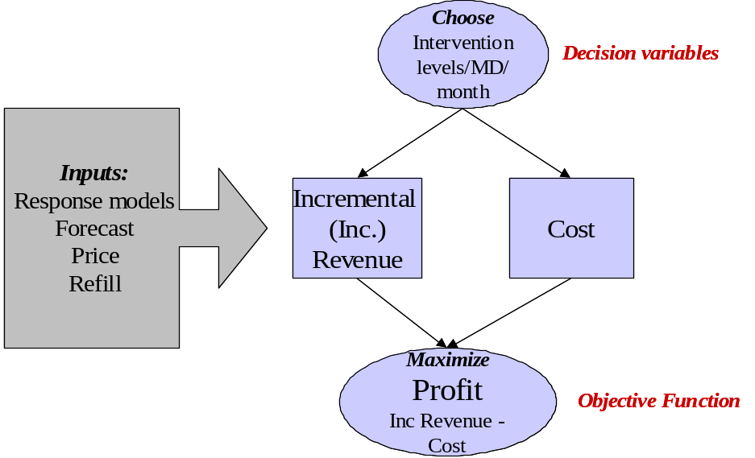

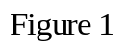

Next, the detailed relation of profit to level of interventions across target groups and channels is described. The physician group description is brand specific. For example, the physician groups for Strattera are a combination of Adult versus Child physicians and specialty whereas for Evista the physician groups are a combination of bone decile groups and specialty. The promotional channels are common across brands (Details, samples, Audio program, Speaker Program, Brand Program, Remote Live, DTC etc.). For simplicity of description, it is assumed that there are three physician groups (1, 2, 3) and three channels (details, samples, programs).

Inc Revenue Calculation

Since there are three groups (1, 2 and 3), the total incremental revenue is:
Inc Revenue=Inc Revenue₁+Inc Revenue₂+Inc Revenue₃
where Inc Revenue_{j} is the incremental revenue from MDs in group j. Inc Revenue_{j} is calculated based on number of MDs in group j, price per TRx, refill ratio, and response models as shown in Figure 2.

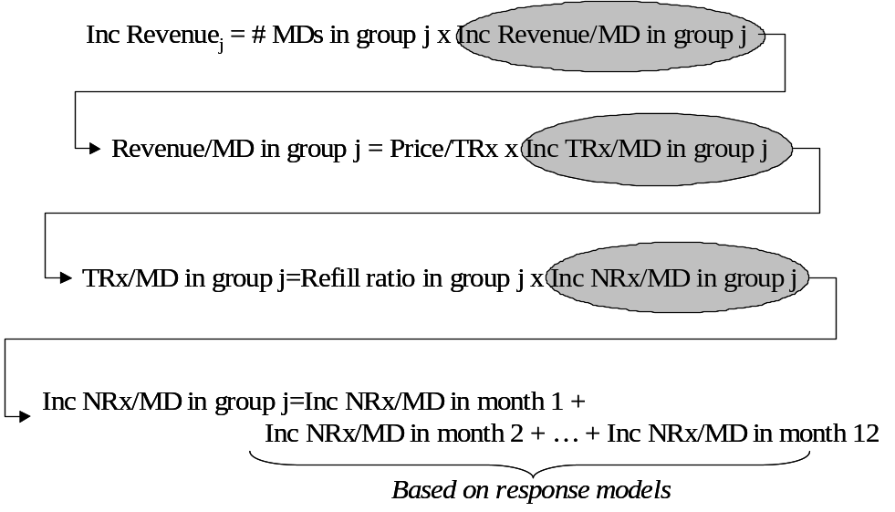

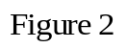

The calculation of NRx/MD for each month based on response models is detailed at the end of this section. Finally, the Inc Revenue is calibrated to forecast using a calibration factor that ensures that the forecast is met with historical effort levels.

Cost Calculation
Cost is calculated as:

Cost=Cost₁+Cost₂+Cost₃

where Cost_{j} is the cost incurred due to interventions in group j. Cost_{j} is calculated as:

Cost_{j}=Cost/MD/month for group j x # MDs in group j x 12
Cost/MD/month for group j = ( Intervention/MD/month x Cost per intervention) totaled over all intervention types (Channels)

In this example, there are only three types of interventions (Details, Samples, Programs) and therefore the cost/MD/month for group j is:

Cost/MD/month for group j=
Details/MD/month x Cost per detail + Samples/MD/month x Cost/sample + Programs/MD/month x Cost per program

Combining the above expressions for revenue and cost results in the following expression for profit:

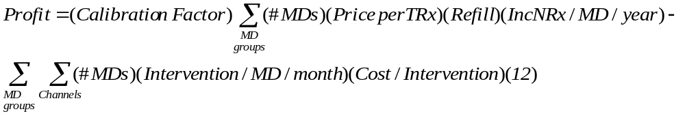

Operational Constraints:

Some of the operational constraints imposed in the model are:
- Maximum allowed/feasible interventions/month/MD. For example:
  - Max details/MD/month <= 4.5
  - Max samples/MD/month <= 18
  - Remote live program/year <= 1
- Maximum allowed details/sample to an MD
  - Samples/Detail <= 10
- Ranking of levels of different interventions
  - Details/MD/month >= Programs/MD/month

Business Constraints:
- Level of spend to certain targets groups. Eg:
  - Total spend on bone decile 7-10 MDs <= 110% of current spend on bone decile 7-10 MDs
- Mix of spend to certain target groups. Eg:
  - Spend on Adult Strattera targets/Total Spend >= 30%
- Level of spend to certain channels
  - Total detail spend <= 105% of current detail spend
- Mix of spend to certain channels
  - Total sample spend/Total spend <= 20%
- Constraint on target revenue
  - Target revenue=forecasted revenue

Calculation of NRx/MD/year from the response model

The response model models ln(NRx+1) at a monthly level using the following functional form:
where NRx_{t} is NRx in month t for an MD. Based on this functional form (and denoting f(interventions) by the symbol a), the expression for NRx in month t is:
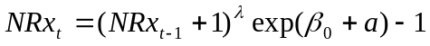
The incremental NRx in month t due to interventions is calculated by subtracting the NRx in month t with no activity (a=0).
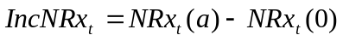
The Incremental NRx/MD for a year is calculated by assuming a starting average NRx/MD at time 0, same activity levels in each month and calculating each month’s IncNRx/MD based on the above formulas. The steps of this calculation are shown in Figure 3 below.
